**“BRASEA” South Australian Variety Awards**

**2013**

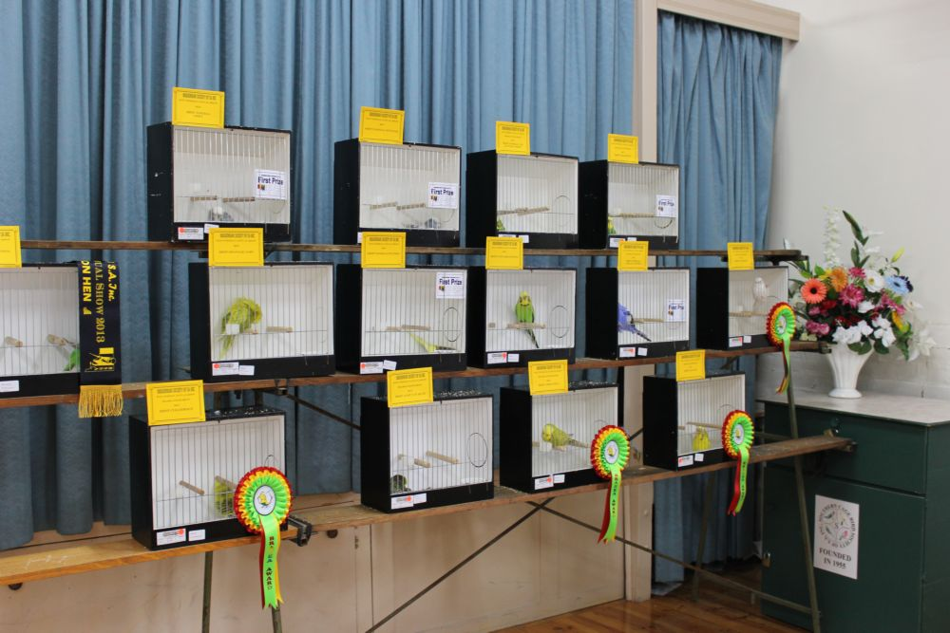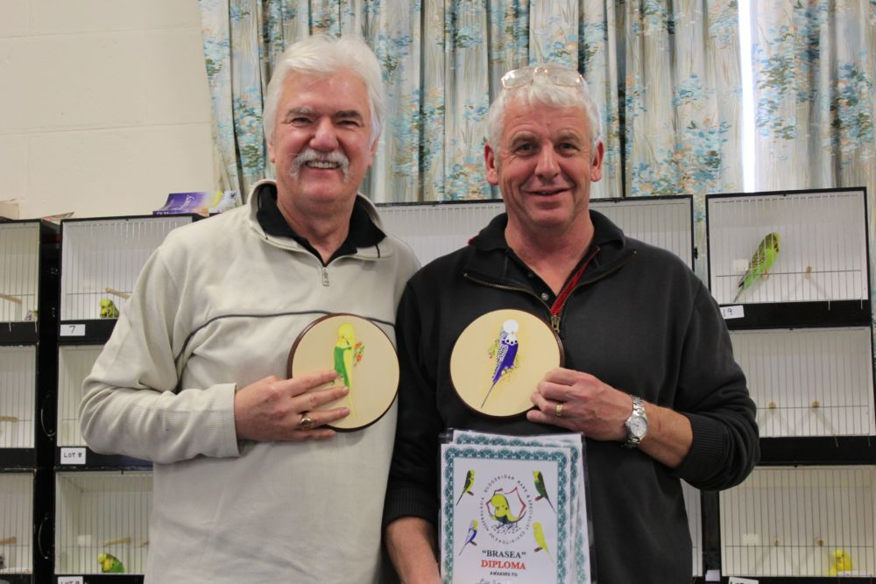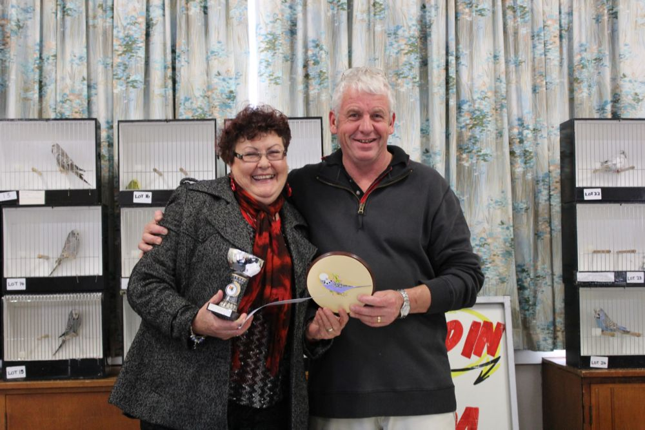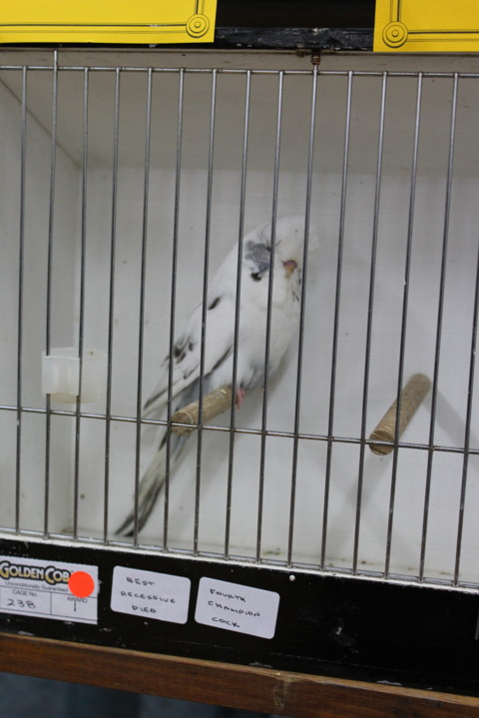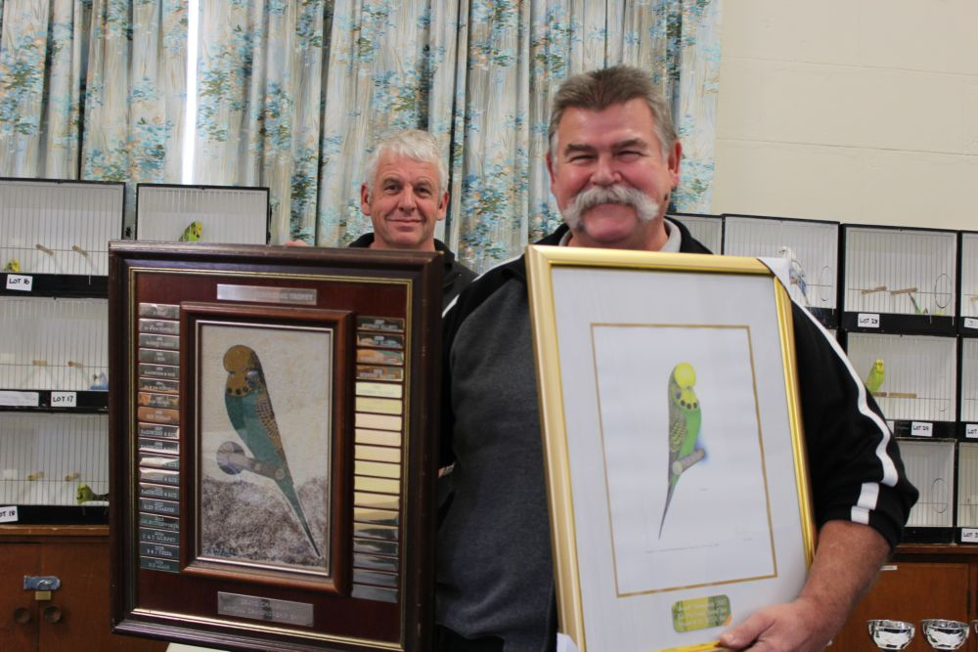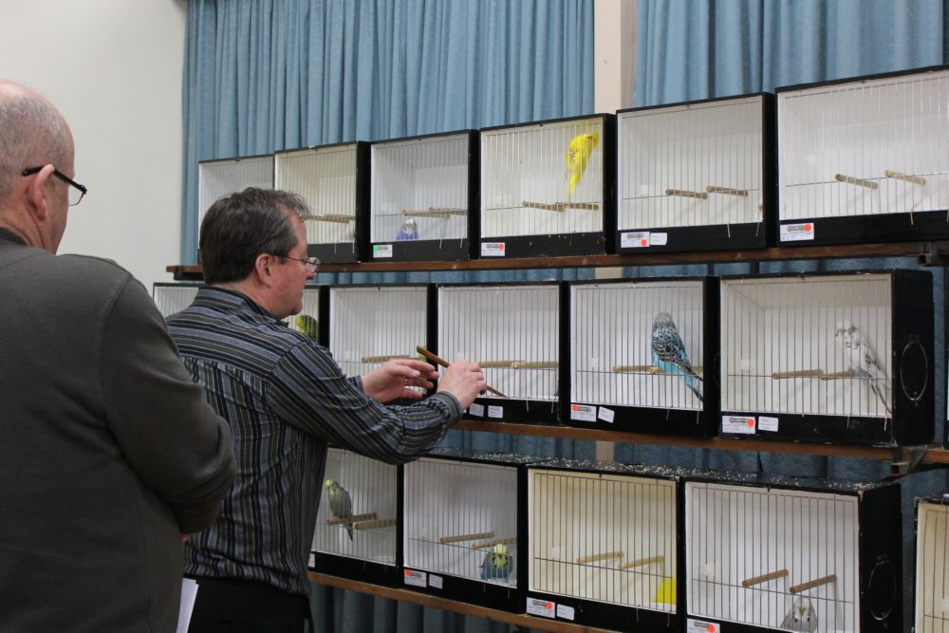

Top L - Jeff Lloyd trying to make it all look good and get it right !!!! Thanks Jeff

Peter Simic’s Recessive Pied

Middle L - Peter Simic & Wayne Weidhoffer just showing off

Sue Adams over the Moon with wayne !!!!

Bottom L - Steve Elliott another big catch of the day - thanks to SA for a great Show .....