BRASEA ONLINE TENDER SALE
THIS TENDER 2020 / 7

OPENS: Wednesday September 16th 2020
CLOSES: 6pm Saturday September 19th 2020

AUCTION STATUS – SELLING
BIRD A  Variety:  Cin Grey Green Spangle Cock | 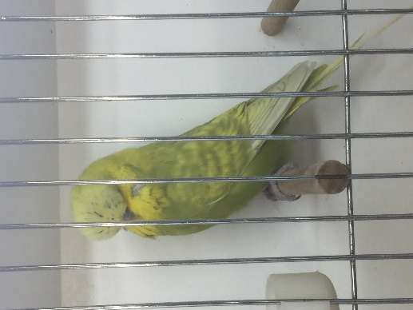 | Breeder:  Mark Chandler  Ring No:  GMC 038-19 | Bloodline:  Very nice bird has it all blow, width, body size Brother to Diploma winner at Riverina budgie show 2020 | BID  $ 100
BIRD B  Variety:  Cin Grey Green Spangle Cock | 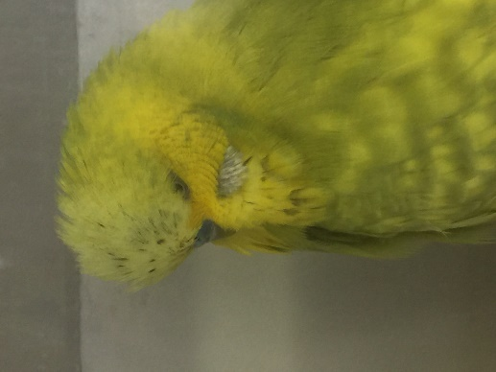 | Breeder:  Mark Chandler  Ring No:  GMC 096-19 | Bloodline:  Very nice Bird surplus to my breeding this year have kept nest brother. | BID  $ 100
BIRD C  Variety:  Cin Grey Green Hen | 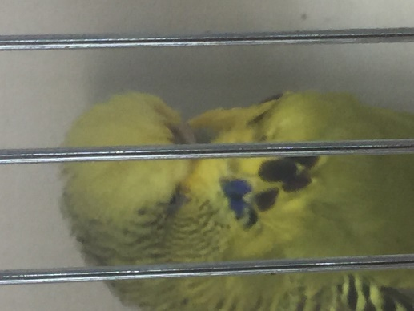 | Breeder:  Mark Chandler  Ring No:  GMC 015-17 | Bloodline:  Large bird very good head width blow large spots and depth of mask. | BID  $ 100  Reserve
BIRD D  Variety:  Yellow Face Sky Hen |  | Breeder:  Mark Chandler  Ring No:  GMC093-19 | Bloodline:  Well put together bird good blow and depth of mask | BID  $ 300
BIRD E  Variety:  Sky Opaline Cinnamon Cock | 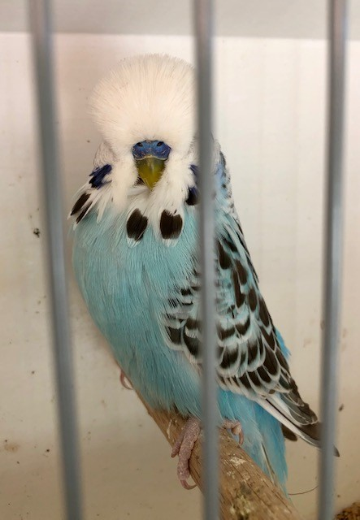 | Breeder:  Matthew Troy  Ring No:  13325/19 | Bloodline:  Hatched 12/12/. Very showy boy with nice spot and head qualities. Mother is half-sister to my National cock and also has Barnett blood | BID  $ 112
BIRD F  Variety:  Light Green Opaline Cinnamon Hen | 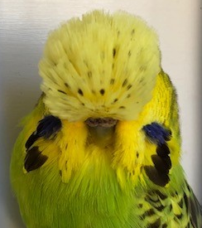 | Breeder:  Matthew Troy  Ring No:  t28 047/18 | Bloodline:  Hatched 03/10/18. Very nice hen with a lot to like have taken chicks last year with good success, perches very nice and loves to show herself. Father was a James Matthew cock and the mother was a daughter of my grand champion. | BID  $ 300  Reserve
BIRD G  Variety:  Grey Green Opaline Cinnamon Cock | 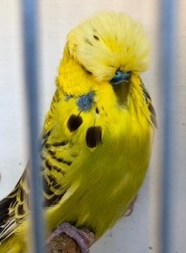 | Breeder:  Matthew Troy  Ring No:  15681/19 | Bloodline:  Hatched 14/12/19. Good young bird breed from the brother to my national cock and a hen that has breed me some successful birds. | BID  $25
BIRD H  Variety:  Spangle Cinnamon Greygreen / Opaline Cock | 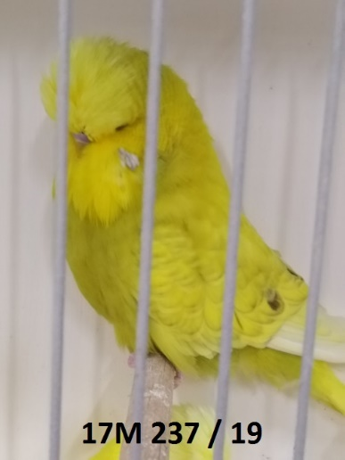 | Breeder:  James Matthews  Ring No:  17M 237 / 19 | Bloodline:  This cock is from a pairing that produced so much quality I had them paired last year and this year as well. They had 14 chicks in 2019 and I have kept 8 in my breeding team, and they had 3 chicks to start this year that have made it into the next cage. One from 2019 is a DF Spangle which I thought was a very good chance to go to the Nationals this year. The sire came 7th at STCC and his father was 6th at the WA Nationals in 2015 and his mother won the Nationals in 2017. | BIDS  $ 350  Reserve
BIRD I  Variety:  Opaline Cinnamon Sky Hen | 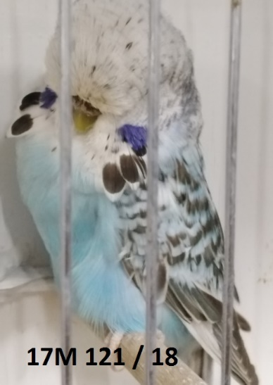 | Breeder:  James Matthews  Ring No:  17M 121 / 18 | Bloodline:  Pairing was to produce Lacewings so of course I get no Lacewings but this handy Opaline Cinnamon hen. As you can see in the photos she has a bit of flecking but her father was a clean headed Cinnamon Grey. Last year I paired her to a Mark Hawke Ino cock and she had 3 full eggs. She hasn't been used in 2020 but looks ready to go down now | BIDS  $ 300  Reserve
BIRD J  Variety:  TBA |  | Breeder: | Bloodline: | NO BIDS $0  Reserve
BIRD K  Variety:  TBA |  | Breeder: | Bloodline: | NO BIDS $0  Reserve
BIRD L  Variety:  TBA |  | Breeder: | Bloodline: | NO BIDS $0  Reserve
BIRD M  Variety:  TBA |  | Breeder: | Bloodline: | NO BIDS $0  Reserve
BIRD N  Variety:  TBA |  | Breeder: | Bloodline: | NO BIDS $0  Reserve

