SALE

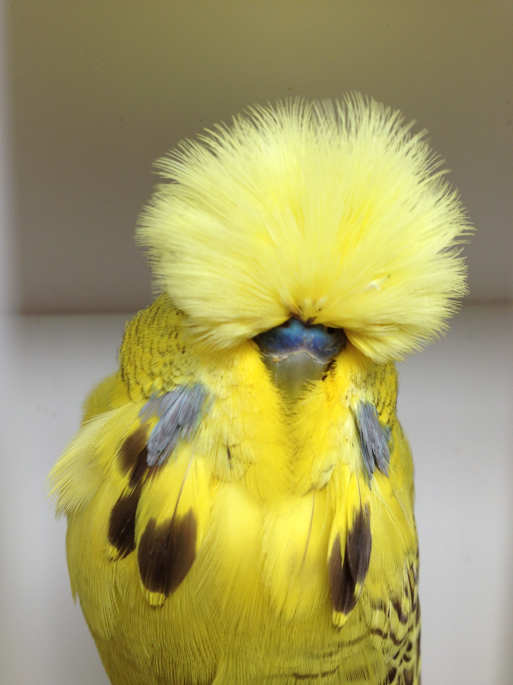

From the Aviary of Tim Corliss
area Weston / Maitland NSW

contact timcorliss@hotmail.com

80 off Split Clearwings and Crest Breds $ 10 each

20 off Clearwings all $20 each
Crests
Cinnamons
Spangles
Opalines
Normals

