NEXT TENDER

OPENS: April 0th 2020
CLOSES: April 0th 2020 at 6pm EST

AUCTION STATUS – OPEN/CLOSED!!!
BRASEA ONLINE TENDER SALE
BIRD A  Variety:  Blackeyed Yellow Cock | 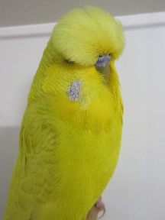 | Breeder:  Name | Ring No:  Number | Bloodline:  Story | NO BIDS $0  Reserve
BIRD B  Variety:  Clearwing Green Hen | 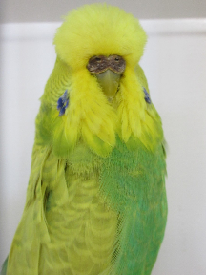 | Breeder:  Name | Ring No:  Number | Bloodline:  Story | NO BIDS $0  Reserve
BIRD C  Variety:  Dilute Green Hen | 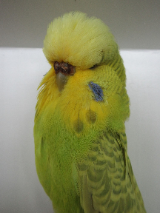 | Breeder:  Name | Ring No:  Number | Bloodline:  Story | NO BIDS $0  Reserve
BIRD D  Variety:  TBA |  | Breeder: | Ring No: | Bloodline: | NO BIDS $0  Reserve
BIRD E  Variety:  TBA |  | Breeder: | Ring No: | Bloodline: | NO BIDS $0  Reserve
BIRD F  Variety:  TBA |  | Breeder: | Ring No: | Bloodline: | NO BIDS $0  Reserve
BIRD G  Variety:  TBA |  | Breeder: | Ring No: | Bloodline: | NO BIDS $0  Reserve
BIRD H  Variety:  TBA |  | Breeder: | Ring No: | Bloodline: | NO BIDS $0  Reserve
BIRD I  Variety:  TBA |  | Breeder: | Ring No: | Bloodline: | NO BIDS $0  Reserve
BIRD J  Variety:  TBA |  | Breeder: | Ring No: | Bloodline: | NO BIDS $0  Reserve
BIRD K  Variety:  TBA |  | Breeder: | Ring No: | Bloodline: | NO BIDS $0  Reserve
BIRD L  Variety:  TBA |  | Breeder: | Ring No: | Bloodline: | NO BIDS $0  Reserve
BIRD M  Variety:  TBA |  | Breeder: | Ring No: | Bloodline: | NO BIDS $0  Reserve
BIRD N  Variety:  TBA |  | Breeder: | Ring No: | Bloodline: | NO BIDS $0  Reserve

