

**ALL ABOUT THE “WHITE CAP”**

A very informative training session was run by Alan Rowe with the assistance of Vanessa White on the video at United Budgerigar Soc., Training session on Tuesday 13th February. The session was well attended by club members, visitors from as far away as Clyde and the Editor of Budgie News, Rod Skivington.

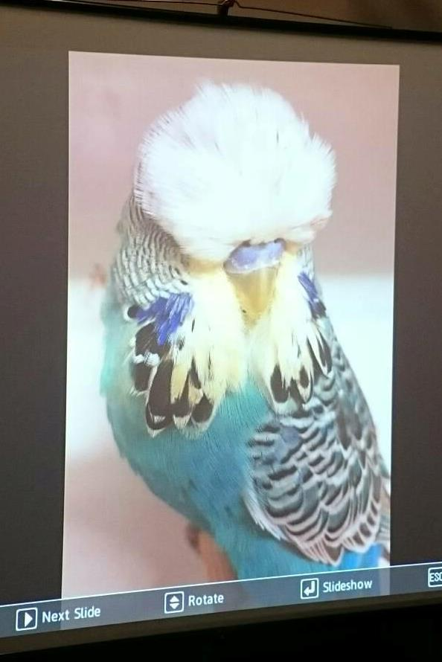

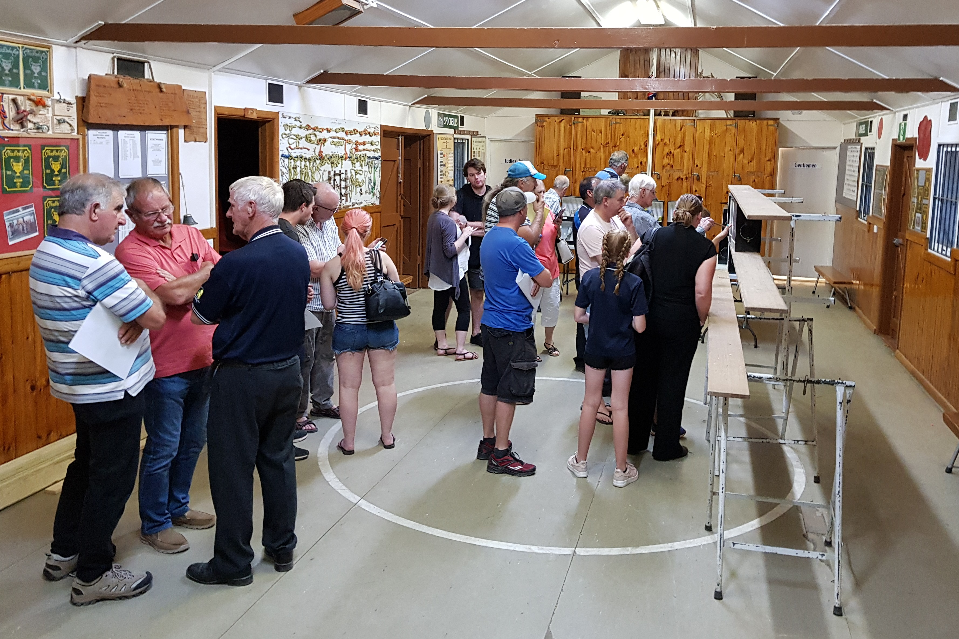

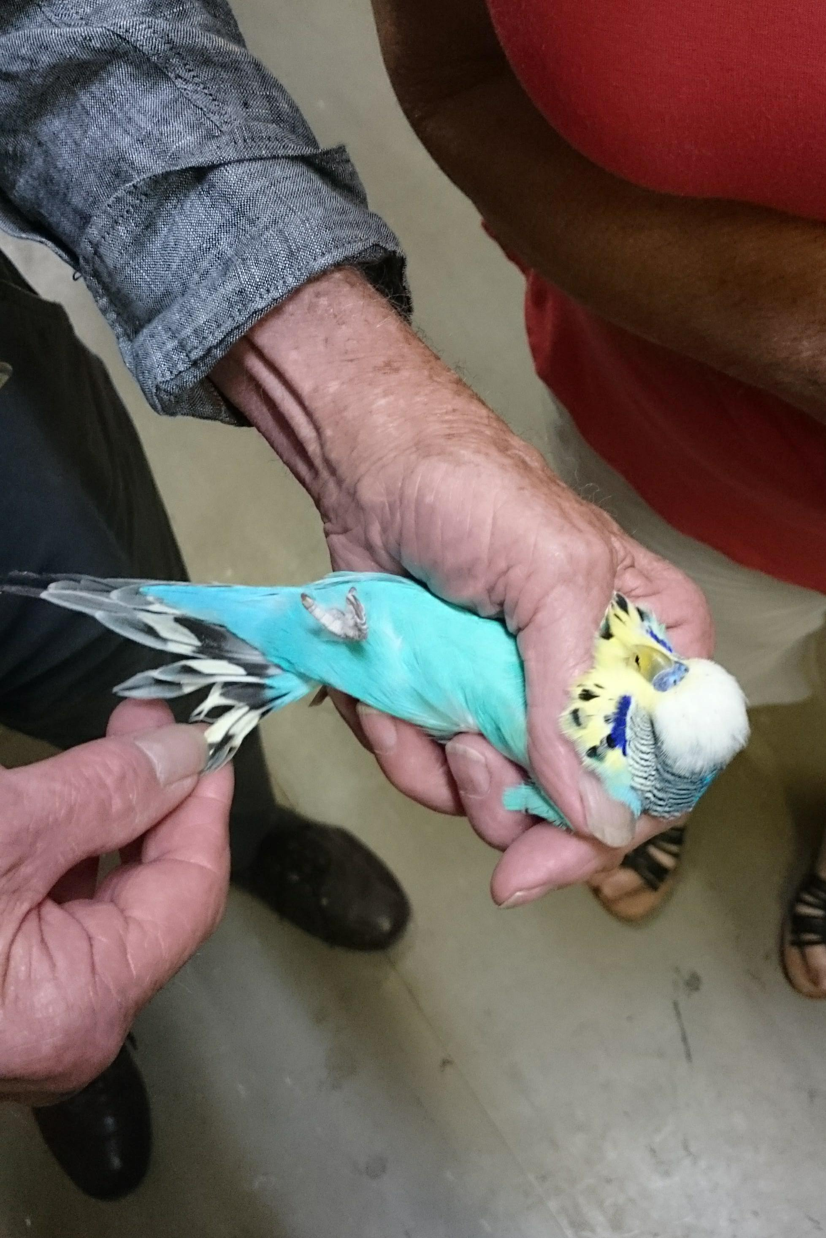

***White Cap Alan showing the yellow covets A great attendance***

**EVOLUTION:**

These birds were first recognized in the aviary of Graeme Kerle of Townsville in 2003 by Kevin O’Callaghan (QLD) who gifted a pair to Jennie Liebich (SthAust) to ensure distance between stock in case of disaster and to better understand the breeding of this variety. Nigel Tonkin (SthAust) after discussion with a fancier and approval of the originators named this new variety “Seafoam” because of the body color produced on the normal sky blue series in this variety.

In 2014 this was changed by the Australian National Budgerigar Council to Australian White Cap.

Don Burke from NSW has also been very instrumental over the last few years in further developing this variety and ensuring the spread of birds around the country, he along with Nigel Tonkin have been involved in gaining a better understanding of the reproduction of the variety, especially the understanding of the Single/Double Factor characteristics.

**GENETICS (Simplified):**

The genetic basis for the WC variety is now well established. WC Greens have been produced by mating two WC Seafoams together - that is NO GREEN parent was used.

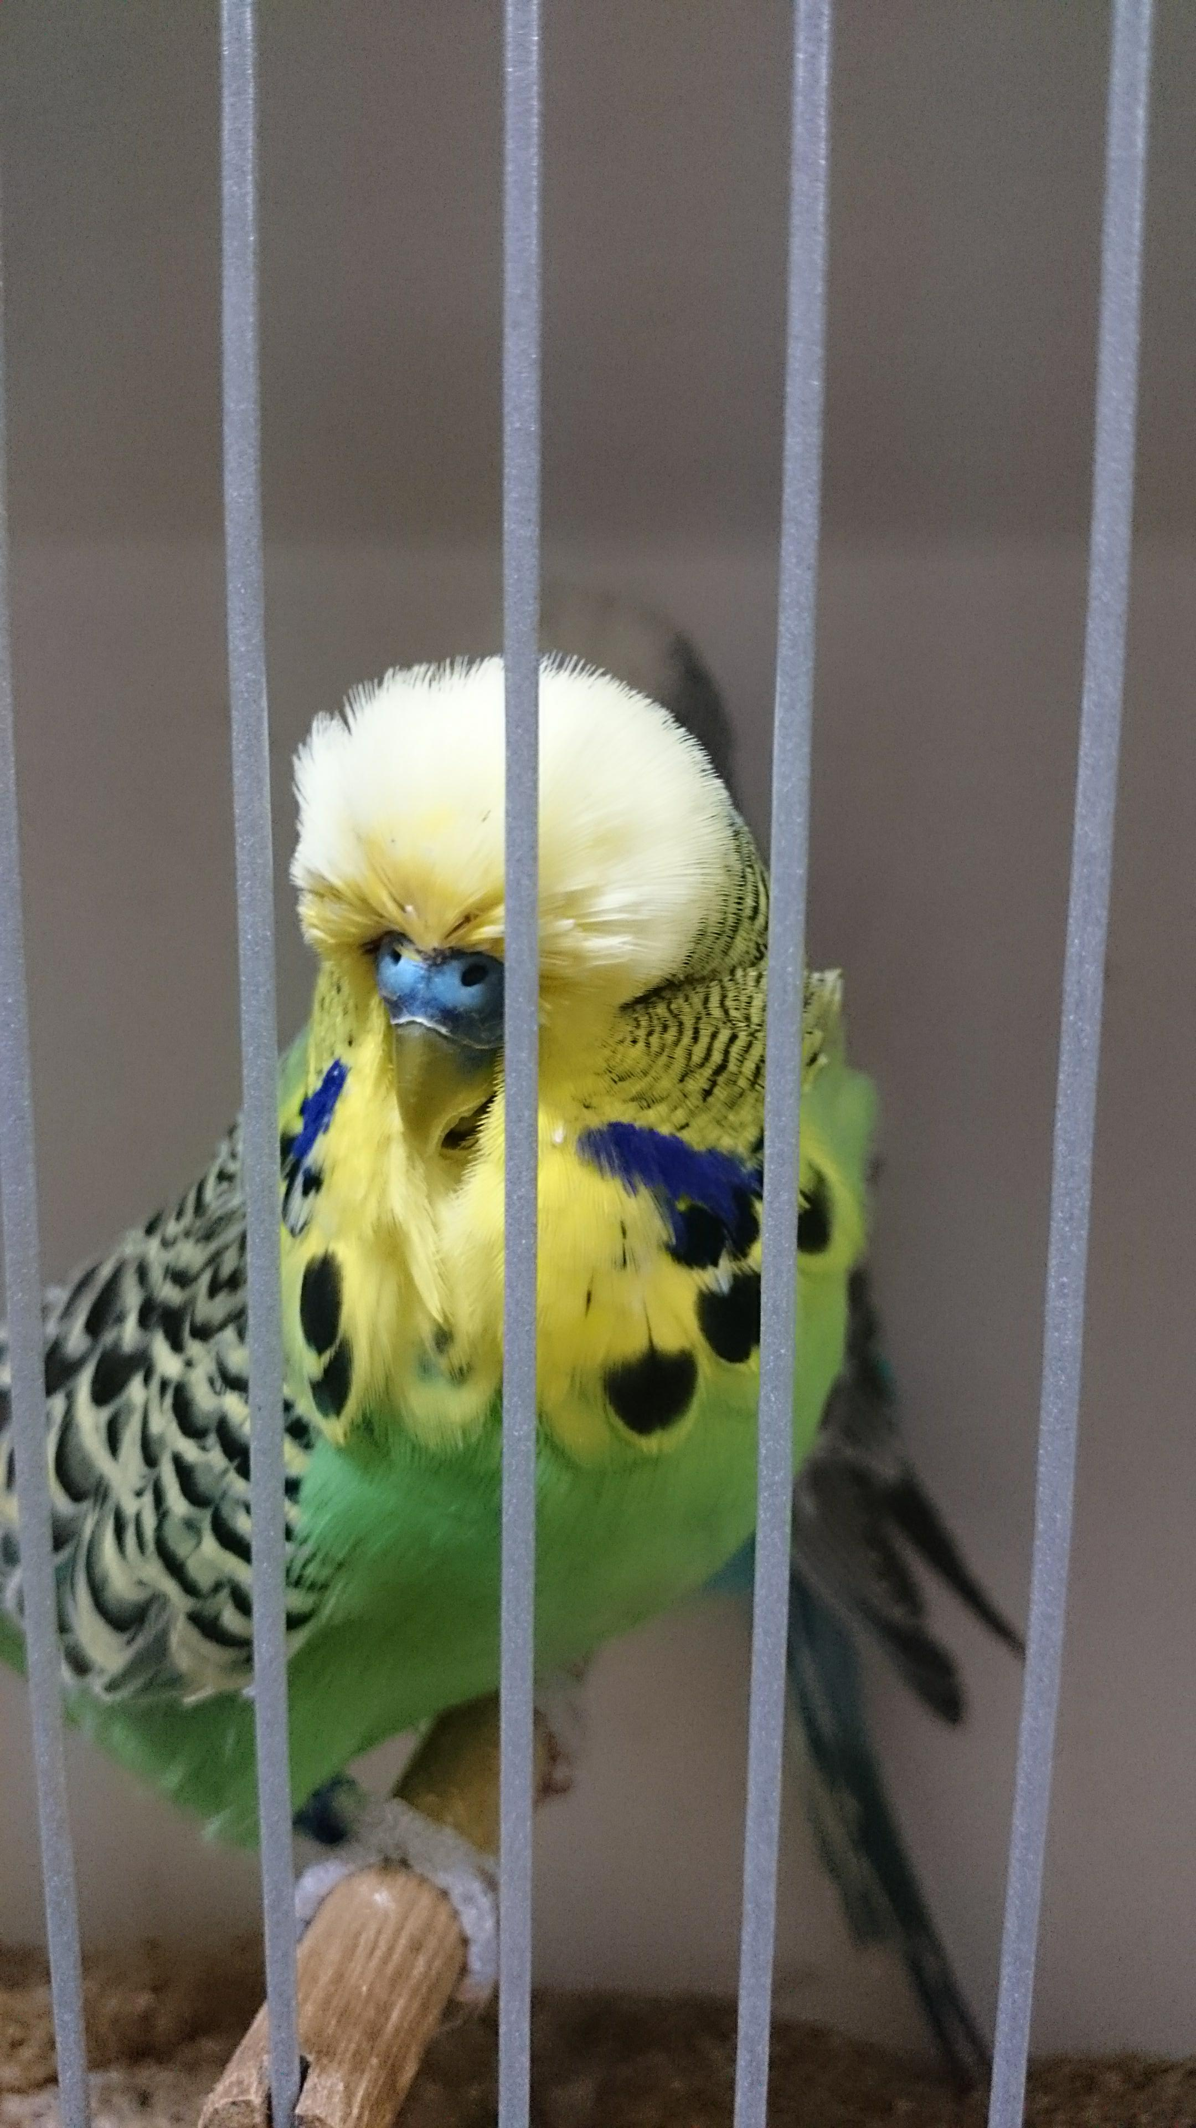

Equally, all WC Greens, when mated to a blue budgie produce 100% WC Seafoams.

**The breeding ratios are considered to be Dominant:**

White Cap Seafoam X Blue* = 50% WC Seafoams + 50% Blues.

White Cap Seafoam X White Cap Seafoam = 50% WC Seafoam + 25% WC Green + 25% Blues.

White Cap Seafoam X White Cap Green = 50% WC Seafoam + 50% WC Green.

White Cap Green + White Cap Green = 100% WC Green.

White Cap Green + Blue = 100% WC Seafoam.

 * By “Blue” means any ordinary Blue variety of budgie.

At this stage, it would seem very foolish to EVER mate any White Cap to a genuine Green budgie. This would confuse things enormously and would probably produce many genuine greens masking White Cap. This would waste many otherwise useful birds.

One observation is that the cream bib colour starts vey light as Unbroken Cap and darkens as the birds go through the moult and get older.