Sydney Annual Lawn Show
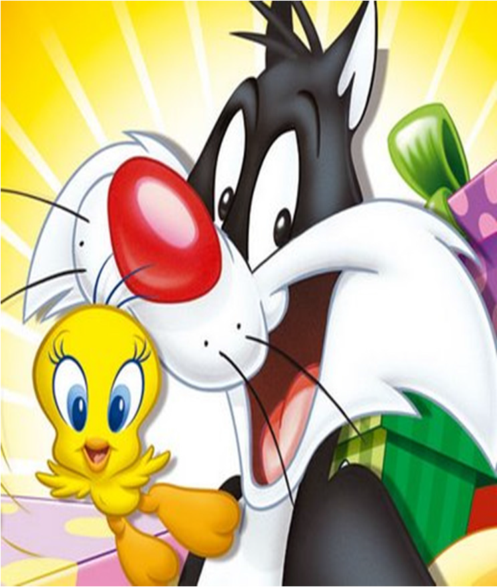

Sunday 24th November 2019 from 9am – 3pm
St Ives Showground 450 Mona Vale Rd St Ives Sydney

Fun day for Everyone – Bird Show and display with specialist classes, Birds for Sale, Pet Bird Section, Gold Coin Raffle with many Christmas and bird type prizes, Picnic with Grazing wholesome picnic lunch, continuous Morning tea, information on joining our Group, fun and bird activities, Small Children Christmas style present – you must register your children for the present and reserve for the lunch $10 adults, $5 children under 16 – for full details & costs contact Warren

warren@brasea.com or phone 02 9747 6642

